**Day 3 Lab**

1. make products page has cards of products and make sort price, filter with category and make search input to search with title

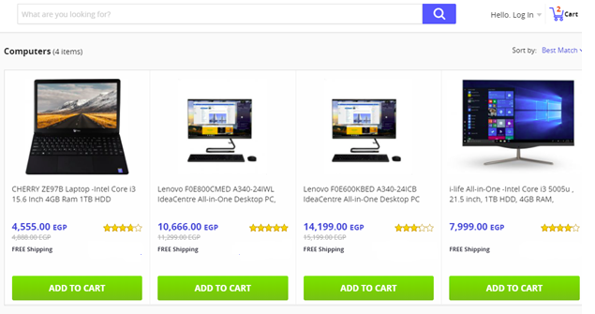

1. Make a registration form

Form fields:

Full Name (Required)

Email (Required, input type: email)

City (Drop-down list filled with some cities)

Password

Register button,

* + When the user focus in any filed text, show red border for the input(use element.style.border=”solid 1px red”), and remove the border when the input loses the focus.
  + Finally when user click Register display all data he write it